ECS (Elastic Container Service)

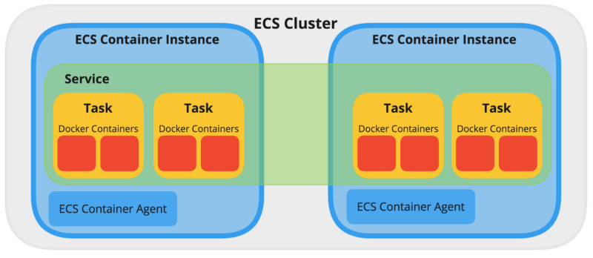

Using ECS we will create a container on AWS without using the commands

To create a ECS we need EC2 instance

Cluster means group of Ec2 instances

ECS automatically creates instances

If we create container manually in case the container gets down again, we should create the container manually

Just we create containers on ECS it will manage the containers, it will check make sure the containers are running are not

In ECS we call container as task

In cluster we give configuration (Ec2 configuration)

Task definition means container definition

First, we create cluster

In cluster we have Ec2 instances

Service

In it We have container Task definition – task definition specifies the container information for application how much resource are use like that

Container Task

Step one open your AWS and got ECS and create a cluster and select Ec2 Linux machine

Here we have ECS agent which is called the Default container which manage all the container in the cluster

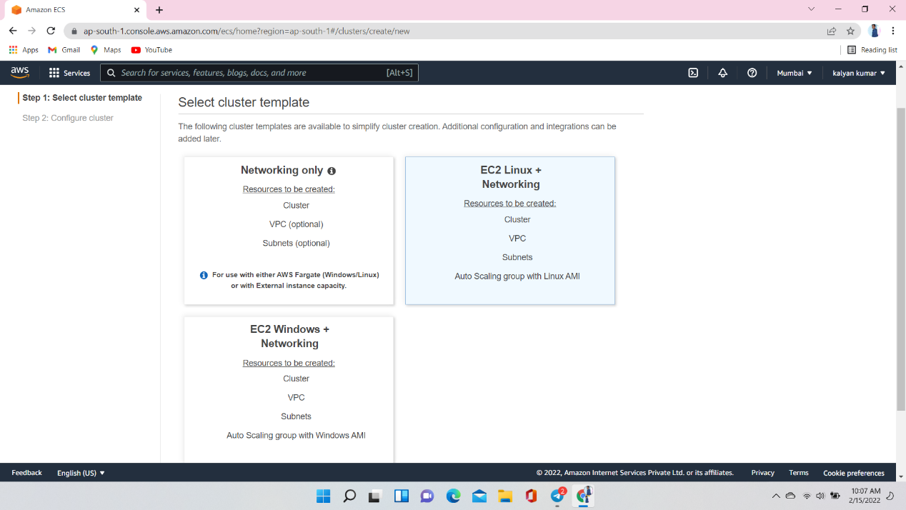



Create a cluster name

Select Provisioning Model is ON-Demand Instance

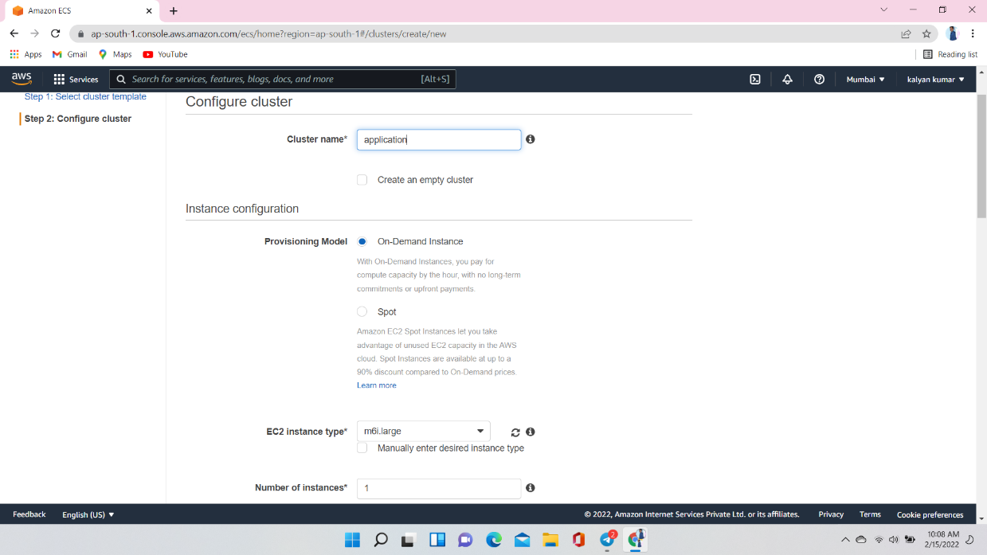

Select Instance type here we have m6i.large and give Number of instances

And give key pair

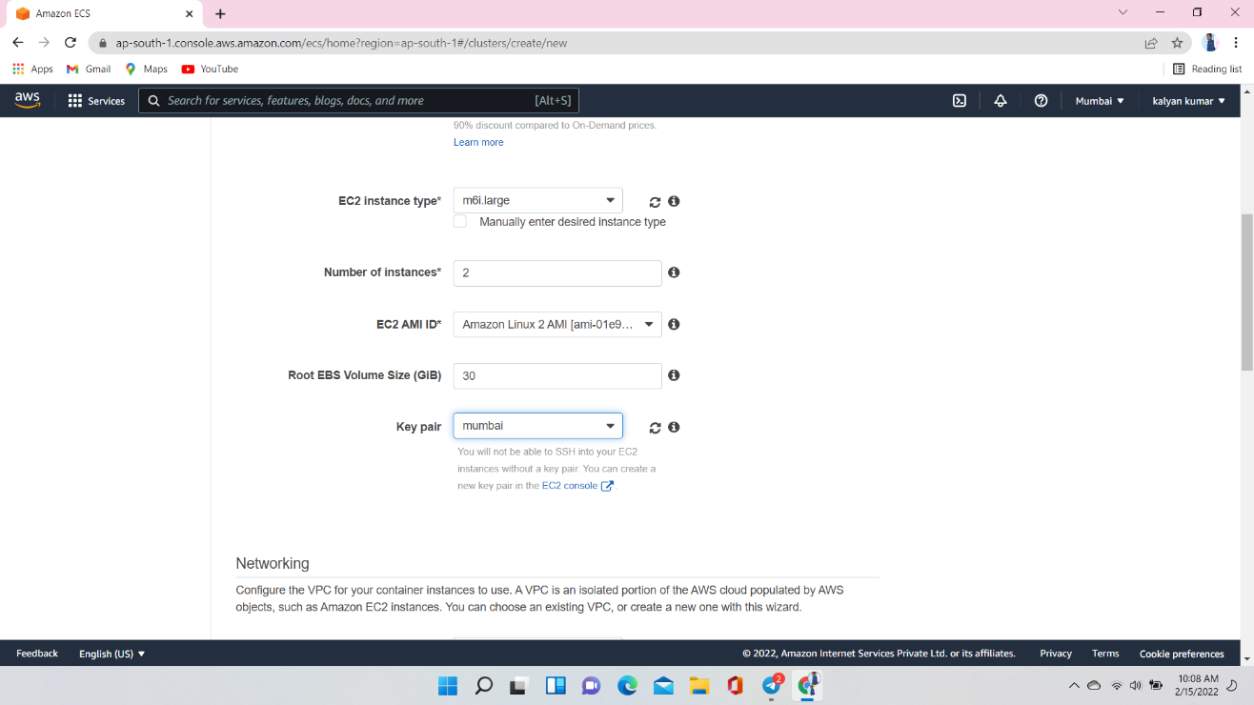

Select vpc here I am selecting default vpc and two subnets

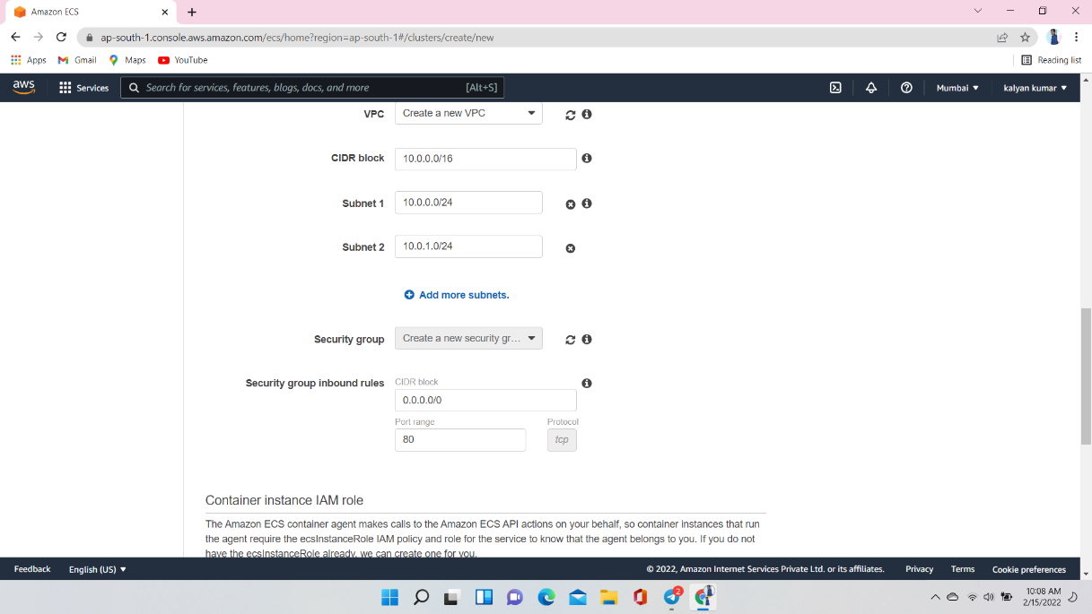

Now Ec2 instance was created in Our cluster

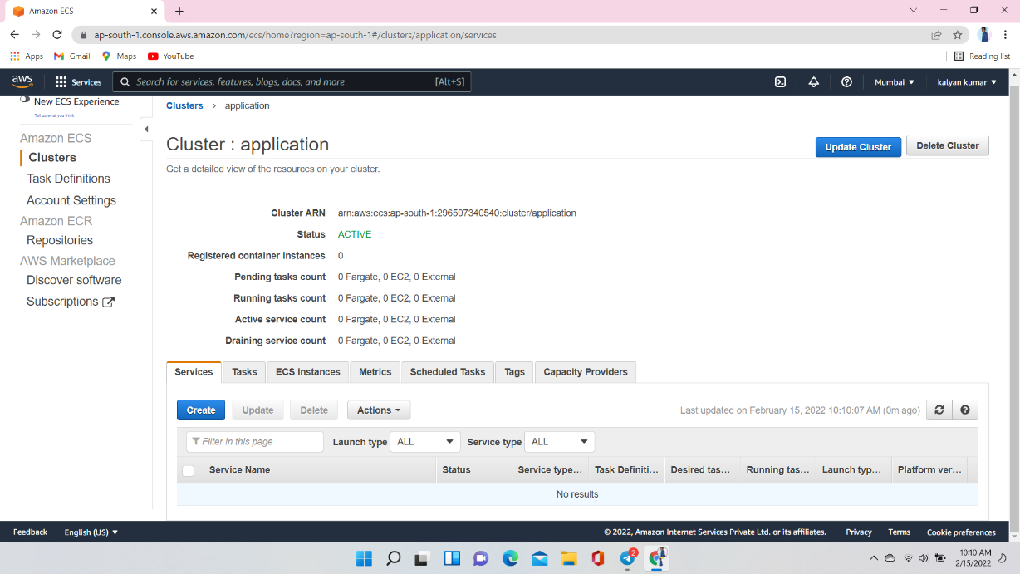

Step 2 create Task Definitions ..

Task definitions specify the container information for your application, such as how many containers are part of you task, what they will use how they are linked together

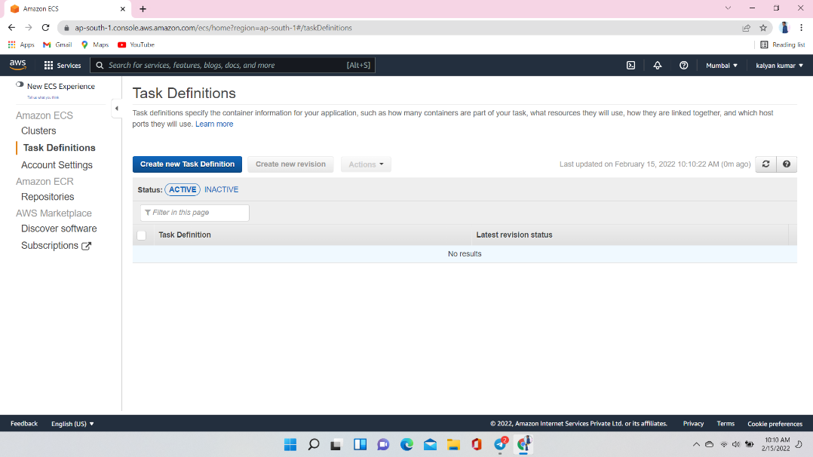

IN Task Definition select launch type compatibility Ec2

Which type you want you task defintion to compatible with where you launch you task

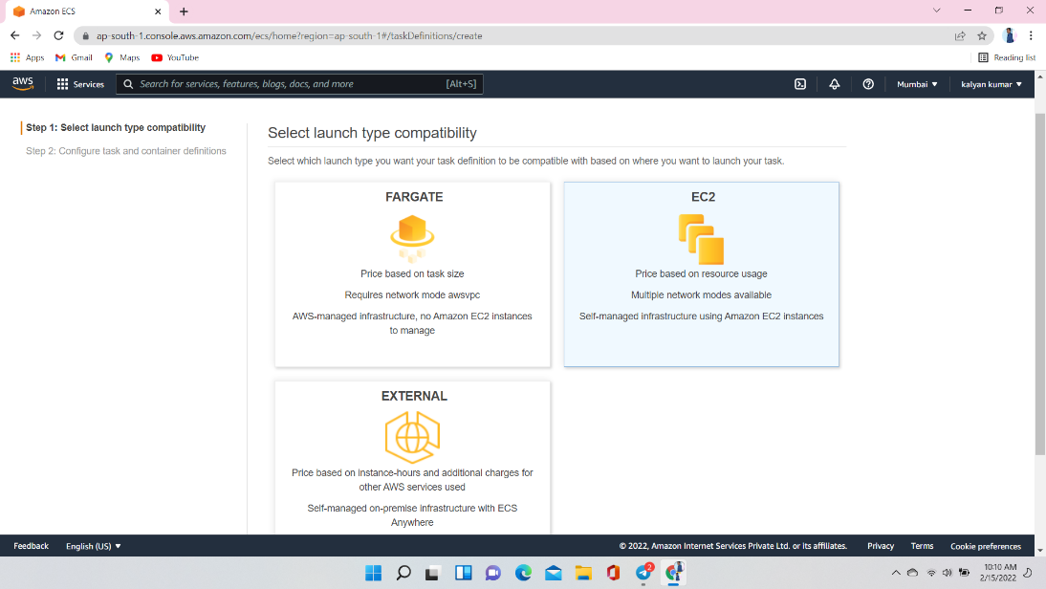

Task definiation – as task definition specifies which containers are included in you task and how they interact with each other. you can also specify date volumes for you container to use

Here give task definion name

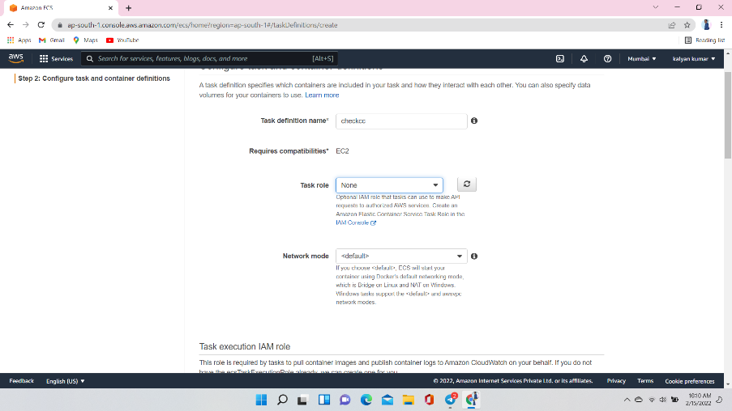

Task memory (hard disk ) here I am giving 500 mb

Task CPU 128

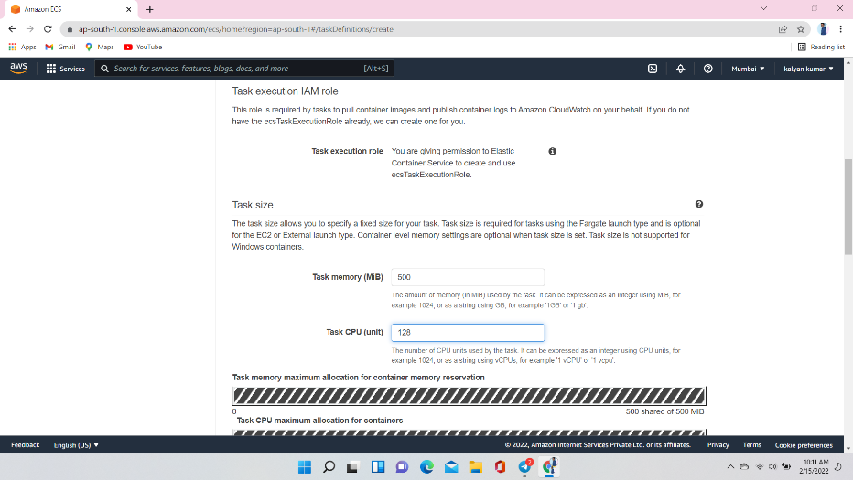

After providing the Ram and hard disk

Add container first mention container name and image which image it will use

And click add

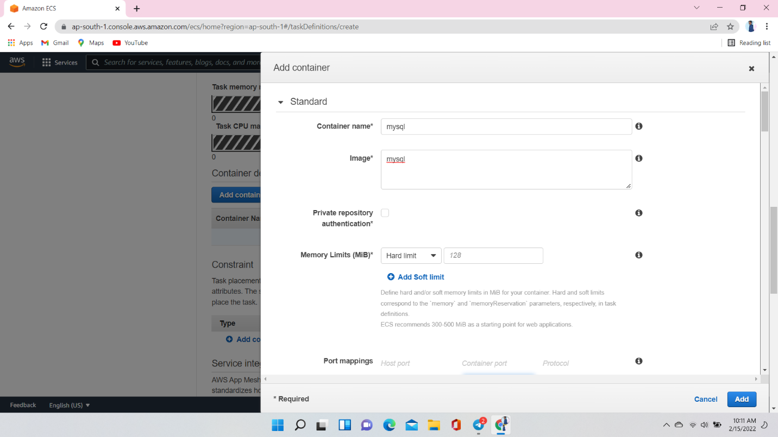

The container added

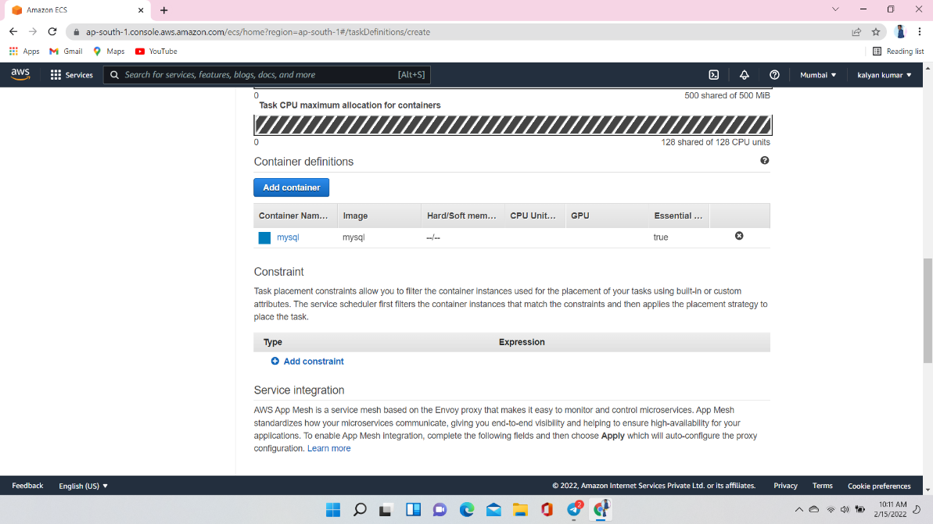

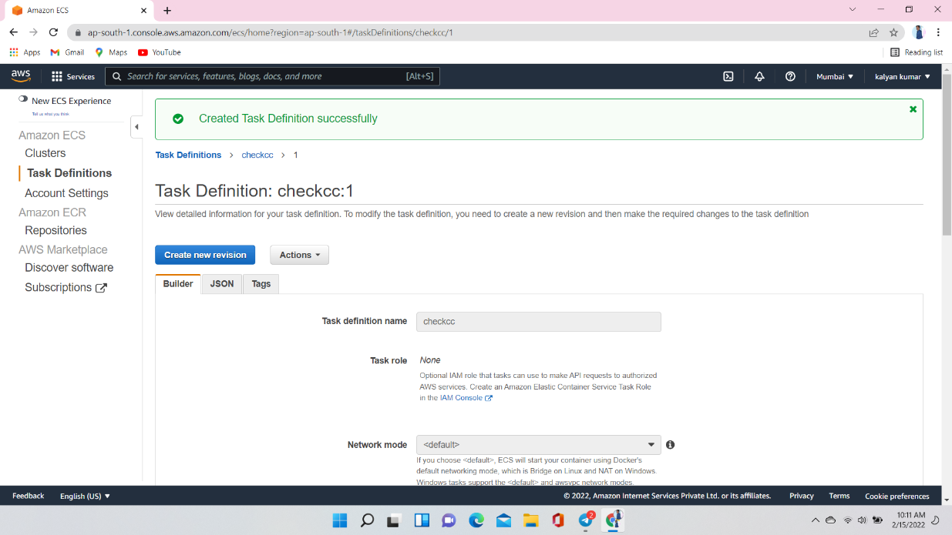

Create a Service :- A service lets you specify how many copies of your task definition to run and maintain in a cluster.

Select Ec2 as launch type

And give Service name which you want to give

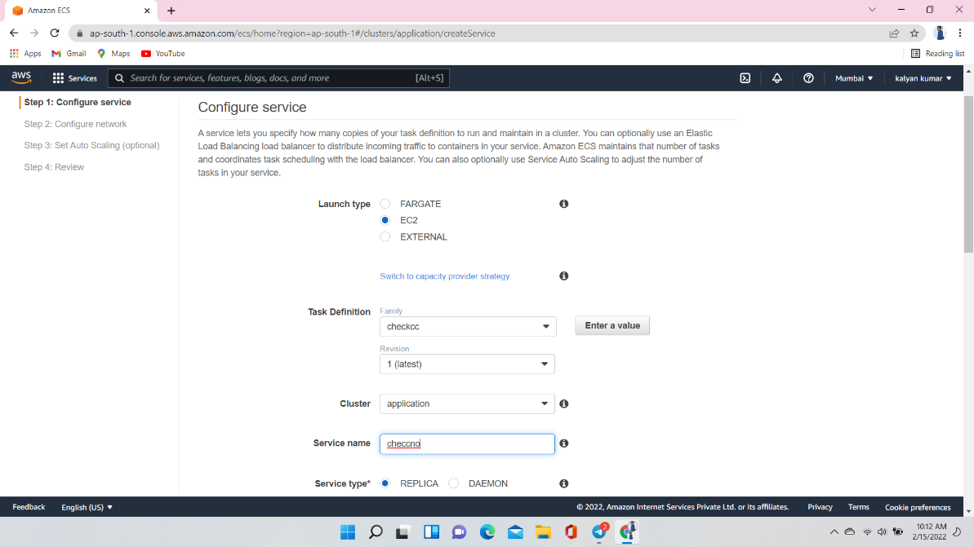

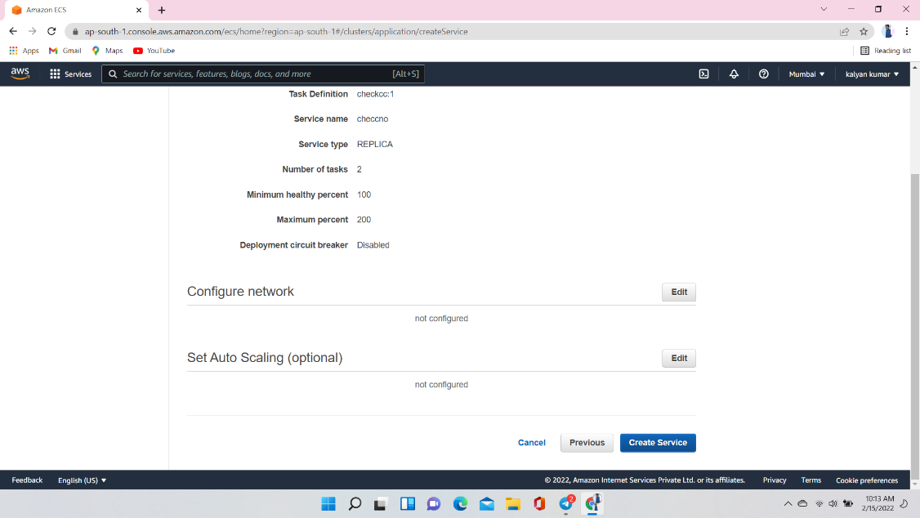

Here you can see num of service and tasks

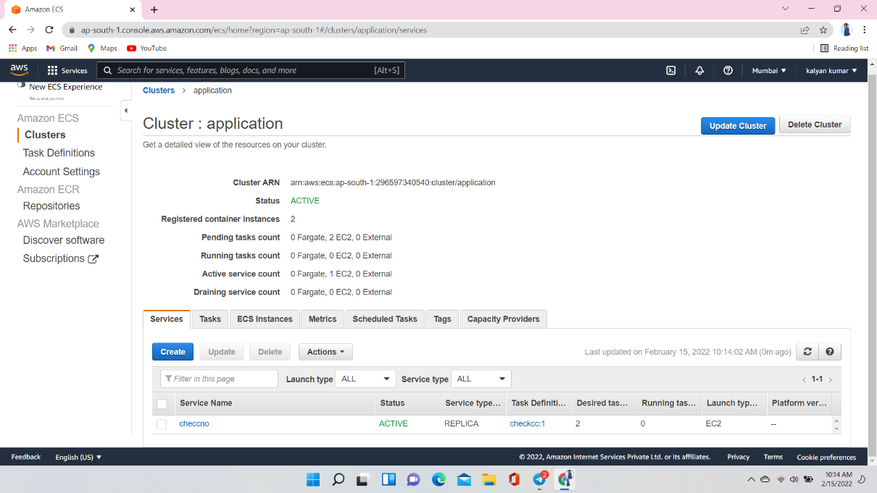

Two instance are created in AWS we created them

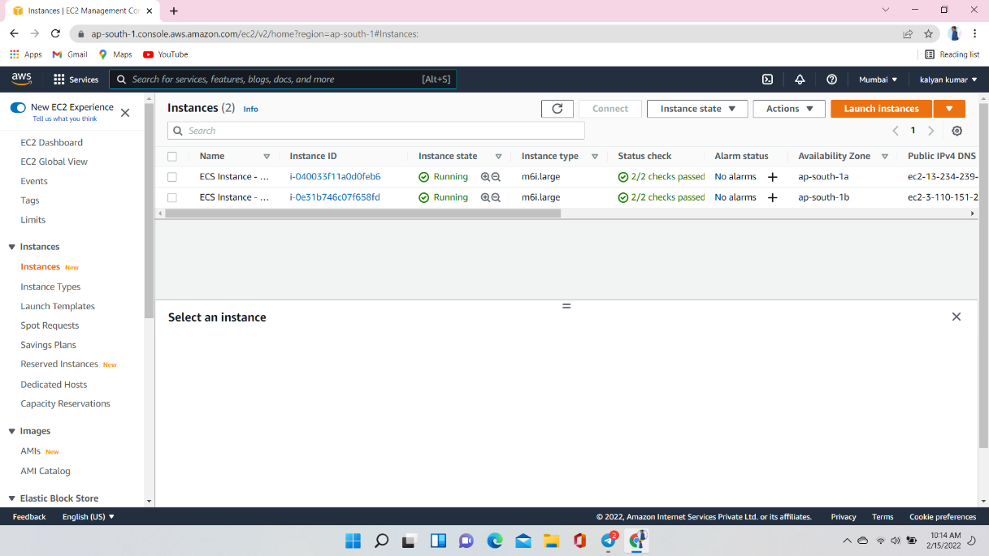

Connect those instances to the terminal and check

In those instances, we have docker it will be come default

Let’s check docker version using command (docker --version)

See how many images are there in it using the command (docker images) here we have mysql image

